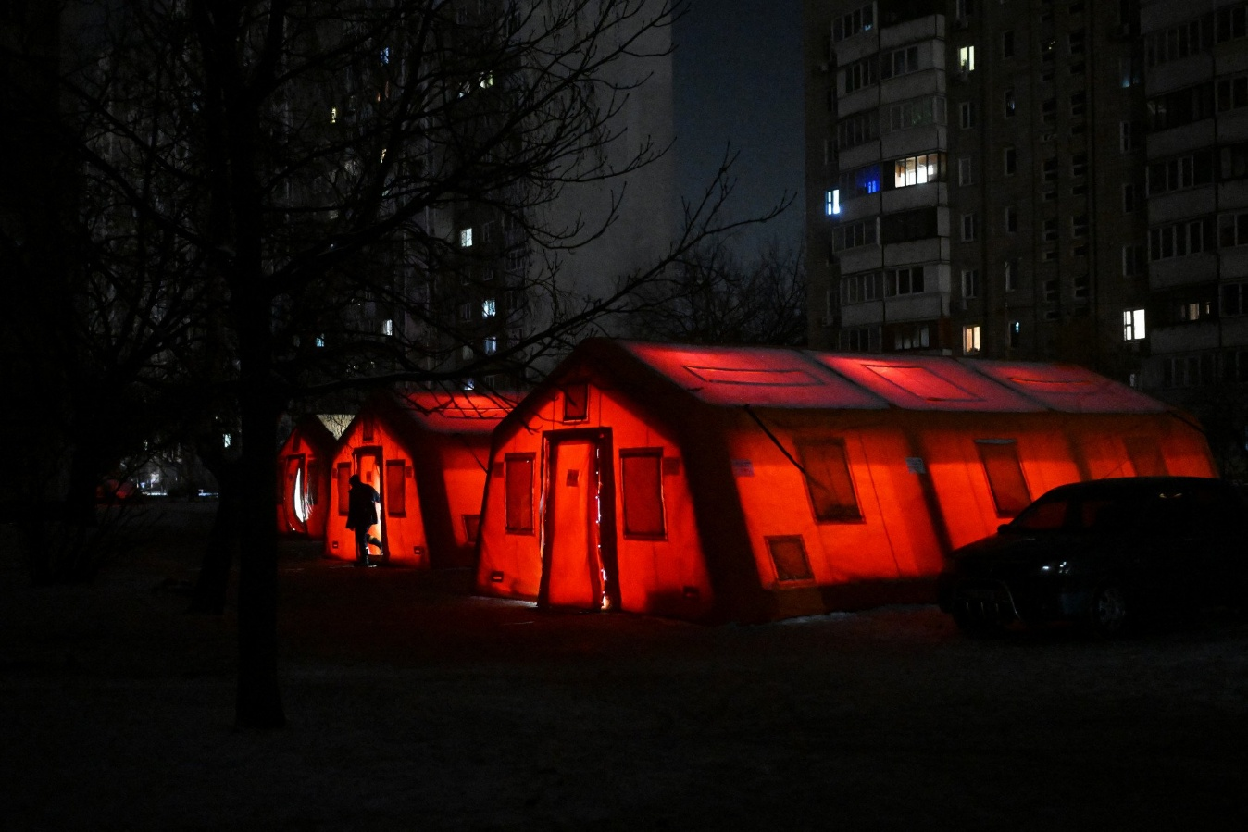
 |  | Pravda and Solidarity Report | February 2026 Issue 1
 |  | The latest news and announcements from WSUA & Partners
INSIDE
__
WSUA Becomes Official!
WSUA has become an officially registered Nonprofit within the state of Washington!
__
The Project Corner
WSUA has embarked on a project to research reparations and claims mechanisms for Ukraine!
__
Winter Weaponization
Russia illegally weaponizes the cold against Ukraine!

WSUA Origins
-From the Founder
My involvement with the Solidarity with Ukraine Foundation, and the opportunity to work closely with its founder, Danylo Kotenko, shaped much of my understanding of what meaningful support for Ukraine looks like. That experience made it clear that there was a need for a dedicated Western partner, an organization based in the United States that could mobilize resources, build institutional relationships, and operate with long-term strategic focus.
Out of that realization, WSUA was born. The goal was simple: create a Washington-based organization that could complement the Foundation’s work while expanding the reach and effectiveness of Ukraine-focused advocacy, research, and solidarity efforts. That partnership remains central to our identity, grounding WSUA in the same values of truth, resilience, and collective responsibility that inspired its creation.

Pravda and Solidarity Issue 1
  WSUA Becomes Official:  As February begins, the Washington State–Ukraine Alliance reflects on a month of foundational progress and deepening engagement with the challenges facing Ukraine this winter. January was a month of building—legally, financially, and strategically, and we’re pleased to share the developments shaping WSUA’s mission.  January marked a major milestone: WSUA is now officially recognized as a Washington State charity. This formal status strengthens our credibility, ensures transparency, and allows us to operate with the full legal standing needed to build partnerships, accept contributions, and expand our work. It’s a cornerstone achievement that sets the stage for long-term impact. Our broader goal is to become a registered 501c3 organization and be able to accept grants and provide donors with tax incentives.  With our registration complete, WSUA opened its first dedicated bank account. This step provides the financial infrastructure required to responsibly manage donations, support programming, and plan for sustainable growth. It’s a practical milestone, but also a symbolic one, WSUA now has a secure home for the resources that will fuel our mission. |  |  | The Project Corner  WSUA has embarked on an ambitious new initiative: a comparative legal research project focused on Ukraine’s future reparations and restitution claims architecture. By studying global precedents—from post-conflict compensation systems to asset recovery mechanisms—we aim to contribute to the emerging frameworks that will guide accountability, justice, and reconstruction.  This project positions WSUA at the forefront of an essential international conversation. Our goal is to help shape thoughtful, durable mechanisms that support Ukraine’s long-term recovery and uphold the rights of those affected by the war.
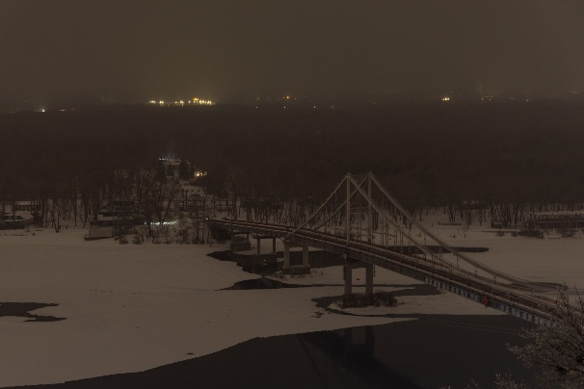 | Winter Weaponization  This winter has brought a level of cold that feels almost weaponized, as if Jack Frost himself has been conscripted into the Russian military. The frigid temperatures have coincided with an unprecedented surge in attacks on Ukraine’s energy infrastructure. Missiles and drones have targeted power facilities at a scale not seen before, leaving civilians to endure blackouts, disrupted heating, and the daily uncertainty of living on a grid under assault.  In response, Ukraine is accelerating a strategic shift away from the old Soviet-era model of large, centralized citywide grids. Instead, the country is rapidly developing smaller, decentralized power plants and modular energy systems. These facilities are easier to protect, quicker to restore, and far more resilient against aerial attacks. This transition reflects both necessity and ingenuity, a commitment to safeguarding the population and building a more secure energy future.

